**跟湯瑪士學英文字母** 姓名: ___________

小朋友，有些列車的字母不見了。請你將下方的字母剪下，將它們依正確的字母順序A-Z貼上，讓列車變得完整好嗎?

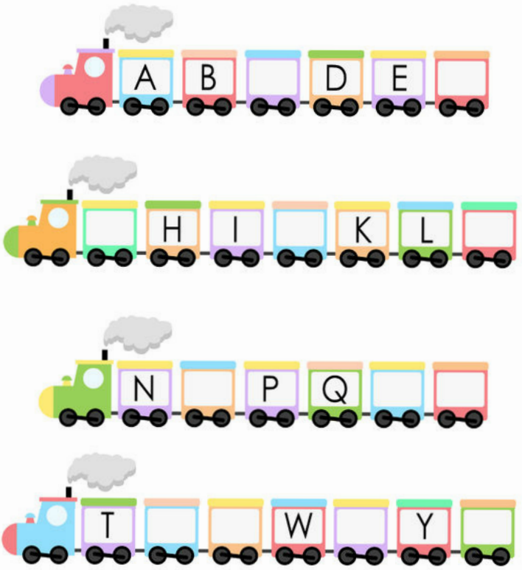

✂-------------------------------------------------------------------------------------------

|  |  |  |  |  |  |  |  |  |  |  |  |
| --- | --- | --- | --- | --- | --- | --- | --- | --- | --- | --- | --- |
| **J** | **R** | **C** | **O** | **V** | **X** | **U** | **Z** | **S** | **F** | **M** | **G** |